**The Greenhouse Effect**

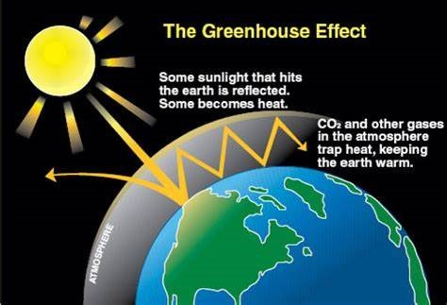The **greenhouse effect** is a natural process that helps maintain Earth's temperature at levels suitable for life. It works by trapping some of the Sun's heat in the atmosphere. Here's how it happens:

* the Sun's energy reaches Earth in the form of shortwave radiation (like visible light).
* Some of this energy is absorbed by Earth's surface, warming it.
* Earth then radiates heat back into space as longerwave radiation (infrared).
* Certain gases in the atmosphere, known as **greenhouse gases**—such as carbon dioxide (CO₂), methane (CH₄), and water vapor (H₂O) – stop some of this outgoing radiation from escaping into space
* This additional radiation is felt as heat and keeps the planet warm.

Without the greenhouse effect, Earth's average temperature would be about -18°C, making it too cold to support most forms of life. So, the **greenhouse effect** is essential for life as we know it.

However, current scientific belief is that human activities have intensified this natural process, leading to what scientists called the **enhanced greenhouse effect**. Since the Industrial Revolution, activities like burning fossil fuels (coal, oil, and natural gas), deforestation, and agricultural practices have significantly increased the concentration of the greenhouse gases (mainly carbon dioxide, CO2 and methane, CH4) in the atmosphere. This extra greenhouse gas traps even more heat, causing Earth's overall average temperature to rise. This extra warming, often referred to as **global warming**, is only a small amount (currently about 1 to 2 0C) is a key driver of **climate change**.

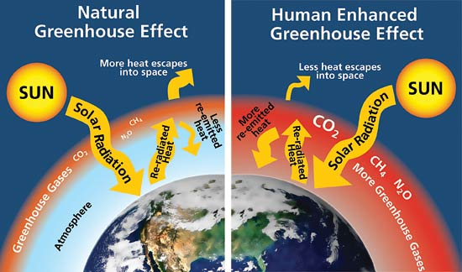The rise in the Earth’s average temperature is thought by scientists to lead to a range of environmental impacts, including melting polar ice caps, more frequent extreme weather events, and shifts in ecosystems. These changes have profound effects not only on natural systems but also on human health, agriculture, and economies.

In summary:

* The **greenhouse effect** is crucial for maintaining Earth's temperature, making it habitable.
* The **enhanced greenhouse effect** results from human activities that increase greenhouse gases, trapping more heat and leading to global warming and climate change.

**Multiple Choice Questions**

1. What is the primary role of the natural greenhouse effect?

a) To produce energy for the Earth  
b) To trap heat from the Sun, maintaining Earth's temperature  
c) To reduce the amount of sunlight reaching Earth's surface  
d) To increase Earth's temperature above normal levels

1. Which of the following is NOT a greenhouse gas?

a) Methane (CH₄)  
b) Water vapor (H₂O)  
c) Oxygen (O₂)  
d) Carbon dioxide (CO₂)

1. What human activities contribute to the enhanced greenhouse effect?

a) Fossil fuel burning and deforestation  
b) Solar panel use and wind farming  
c) Recycling and tree planting  
d) Ocean cleaning and wildlife protection

1. How would Earth's temperature change without the natural greenhouse effect?

a) It would be much warmer  
b) It would remain the same  
c) It would be much colder  
d) It would fluctuate unpredictably

1. What is a potential effect of the enhanced greenhouse effect?

a) Reduction in global temperatures  
b) Increase in polar ice cap size  
c) More frequent extreme weather events  
d) Decrease in atmospheric CO₂ levels

**Short Answer Questions**

|  |
| --- |
| 1. Explain how the natural greenhouse effect helps to keep Earth's temperature suitable for life. |
|  |
|  |
| 1. What is the difference between the greenhouse effect and the enhanced greenhouse effect? |
|  |
|  |
|  |
| 1. Name three greenhouse gases and explain their role in the greenhouse effect |
|  |
|  |
|  |
| 1. How does deforestation contribute to the enhanced greenhouse effect? |
|  |
|  |
| 1. What are some environmental impacts of the enhanced greenhouse effect? |
|  |
|  |